**JEROO FINAL PROJECT**

Brandon Shen

Remington P1

Lab Goal: The goal of this lab is to get the Jeroo, Bob, through the obstacle course without hitting any flowers, nets, or the water. One must use custom methods and conditional if statements to solve this puzzle.

Lab Description: This lab is made to further the users understanding of while loops, conditional if statements, and booleans. One must use all of these components in their final product.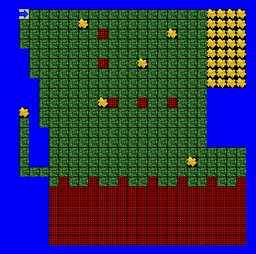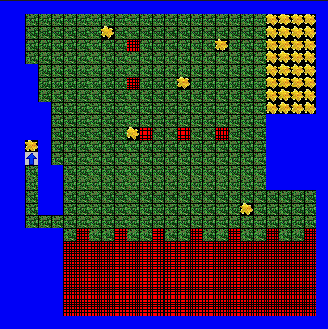

**START SCREEN END SCREEN**

Required Files: BrandonShenFinal.jsc, BrandonShenFinal.jev